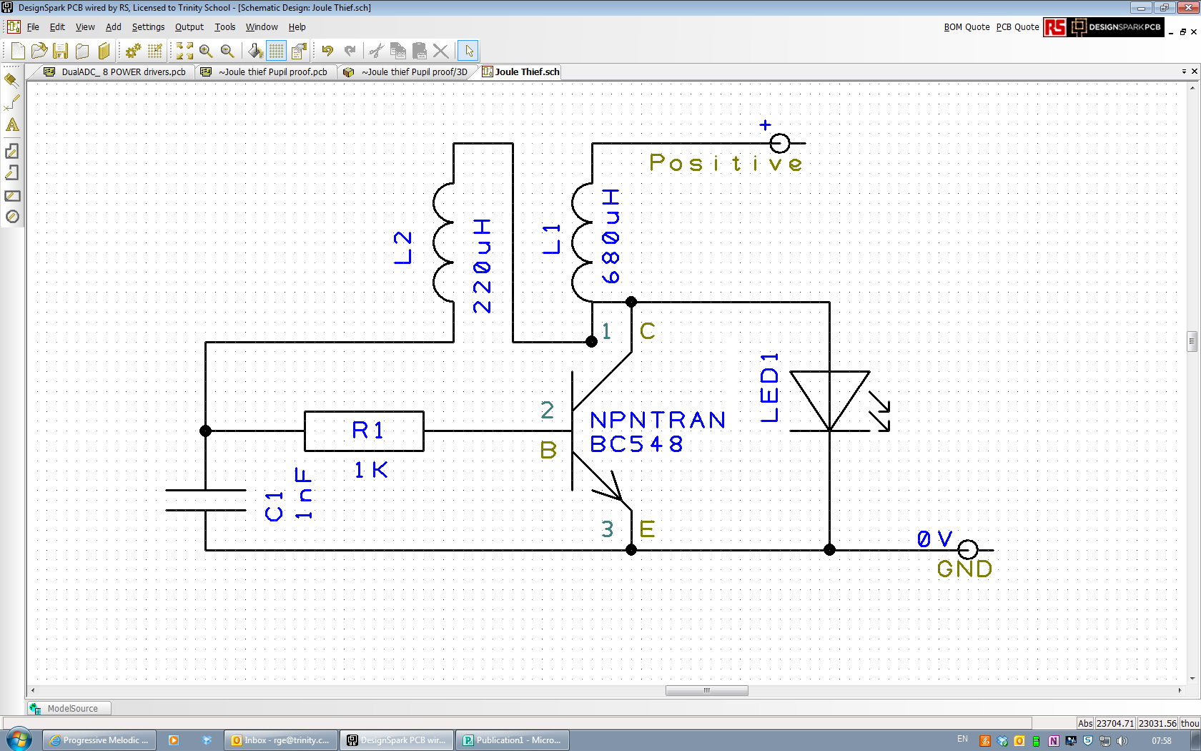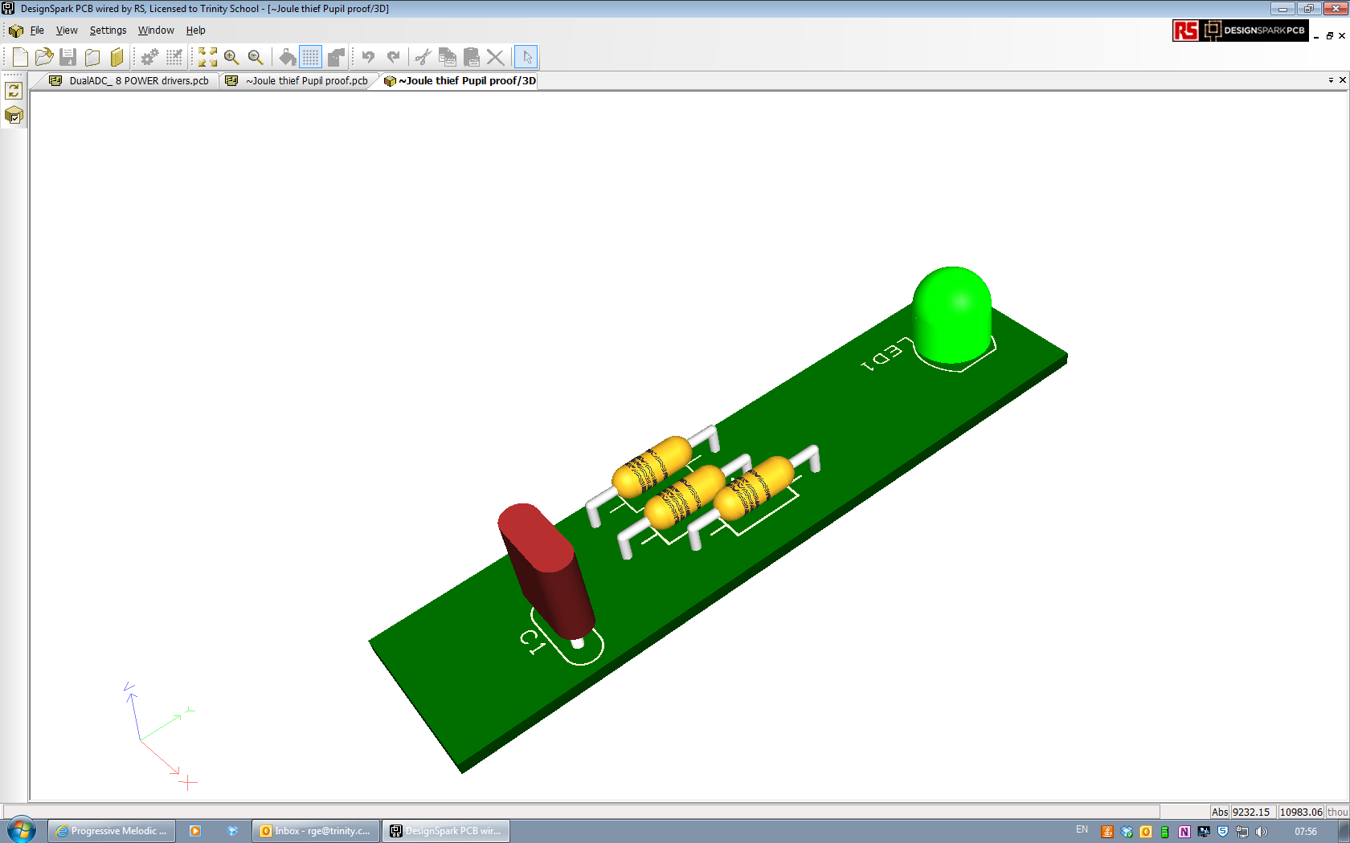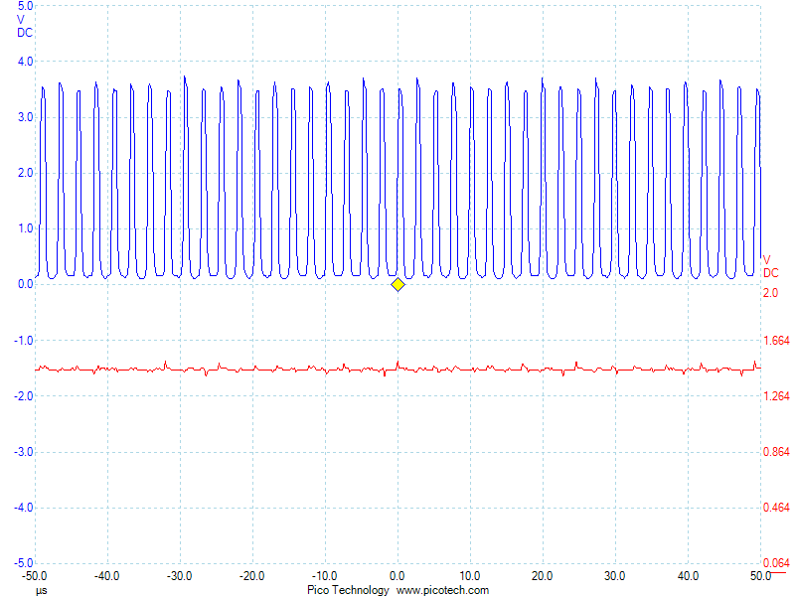

**Joule Thief—let’s get technical….**

Circuit diagrams are like a road map for Electronics—they show you how different components are connected together in a circuit and also the values and part numbers.

Designspark is free electronics CAD software that runs on PCs—you can download it from www.picaxe.co.uk and at the same time install the Picaxe library and the Programming editor software for Picaxe chips which you might use in year 3 or GCSE/A level. They are all free.

One nice function of Designspark is its ability to show you a 3-D rendition of the circuit board that you have designed. This is useful to designers, just like any good CAD is, as it allows you to check things fit before you commit to making.

The final image is a PICOSCOPE trace - the modern PC based version of an Oscilloscope (or CRT) which you may have used in Physics. What it shows is the input voltage to a Joule thief (RHS column, about 1.3 volts) against the Voltage across the LED, in this case about 3.5 volts. Notice that the LED waveform is also switching off and on. It is this principle that allows it to increase the voltage, similar to how the ignition system works in a petrol-engine car. The difference is that this is switching on and off at about half a million times a second. Your eye cannot react that quickly, so you see the LED as on all the time. Most modern power supplies (phone chargers, PC and laptop power supplies) work in a similar way. They are more efficient that older linear power supplies, using less electricity in standby mode and less materials in their manufacture. Their only failing is that cheap units can produce radio frequency interference. Good design can and should prevent that.